**Cherish your life, Cherish your health!**

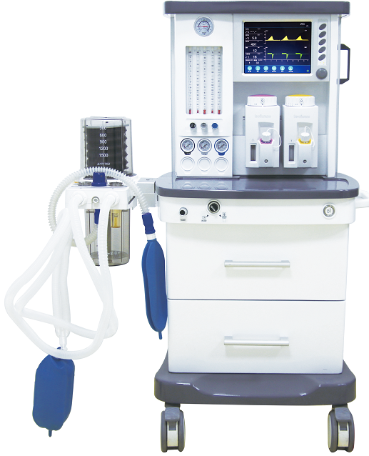

**S6100 Anesthesia System**

**Friendly Powerful Reliable**

**Application：**

The Anesthesia machine makes a good performance in Intensive Care Units (ICU), Operation room, Anesthesiology Department and other departments. From high to low acuity, simple to complex cases, pediatric to geriatric patients, Our Anesthesia Systems offer you the choices you need in ventilation, monitoring and technique. what’s more, our expertise in anesthesia delivery and ventilation is based on rich 23-year history of developing anesthesia solutions that meet your needs. Good performance based on High Security, High Accuracy, High Stability and accurate monitoring.

**Trust Points**

* Simplicity: easy to use, easy to move with 4 wheels.
* Choice: adapt the equipment to your patients and procedures freely
* Patient Centered Ventilation: Precision in an anesthesia ventilator, from conventional ventilation to advanced modes, including 5 modes: IPPV; A/C; PCV; SIMV; SIGH.
* Designed and manufactured with over 23 years experience in this area.
* Flexible configurations to suit your needs.
* International standard and advanced technology suitable for wide range use.
* Compact interface and big screen give you better operating experience.
* Over 2,000 units installed in the world.

**Features**

* 10.4” TFT LCD screen displays the Ventilation parameters, Alarming information and Waveform.
* High precision flow meter, instantly know the fresh gas flow to your patient.
* Integration breathing circuit design, ensure easy operating and keep tidy.
* Multiple working modes such as volume control and pressure limit, adapt to wide range patient.
* Vaporizer with temperature, flow compensation and self-lock function, keep safety anytime.
* Multiple parameters monitoring interface, make every parameter clear, let users know the patient conditions in all aspects;
* Real time pressure-time, flow-time loop graphics and high precision O2 concentration detection function included.
* Vital sign monitor and Anesthetic gas monitor are optional.
* ETCO2 module is optional.

**Safety**

* Three level alarming system, visual and sound alarm information.
* With lots of alarming, reminding and protection functions.
* Advanced power management control technology.
* With built-in backup power source, when outside power source goes off, back-up power source starts to work.
* Low O2 pressure alarm and N2O cut-off protection.

**Specifications**

|  |  |
| --- | --- |
| Ventilation modes: | IPPV; A/C; PCV;PSV; SIMV; SIGH |
| Ventilator parameter ranges |  |
| Flow meter | O2(0.1-10L/min) |
|  | N2O(0.1-10L/min) |
|  | AIR(0.1-10L/min) |
| Rapid oxygen supply | 35L/min-75L/min |
| Tidal volume(Vt) | 0, 20 mL ～ 1500 mL |
| Frequence（Freq） | 1bpm ～ 100 bpm |
| I/E | 4:1～1:8 |
| PEEP | 0cmH2O ～ 30 cmH2O |
| Pressure triggering sensitivity（PTr） | －20 cmH2O ～ 0 cmH2O（Based on PEEP） |
| Flow trigger sensitivity （FTr） | 0.5 L/min ～ 30 L/min |
| Pressure control (PC) | 5 cmH2O ～ 60 cmH2O |
| SIGH | 0(off) 1/100 ～ 5/100 |
| Apnea Ventilation | OFF，5 s　～ 60 s |
| Pressure Limit | 20 cmH2O ～ 100 cmH2O |
| Monitored Parameters |  |
| Frequence（Freq） | 0 /min ～ 100 /min |
| Tidal volume(Vt) | 0 mL ～ 2000 mL |
| MV | 0 L/min ～ 100 L/min |
| Oxygen concentration | 15 % ～ 100 % |
| Graphical display: |  |
| P-T(pressure – time) |  |
| F-T(flow – time) |  |
| P-V loop (pressure – volume loop) |  |
| Size  Wooden case packing size：L 770*W 890*H 1535mm ,  GW：151KG ; NW：91.2KG  Alarm and protection | |
| The AC power failure alarm | Power failure or no connection |
| Internal battery backup low voltage alarm | ＜11.3±0.3V |
| No tidal volume | ≤5Ml within 6s |
| High oxygen concentration alarm  Low oxygen concentration alarm | 19%-100%  18%-99% |
| High Airway pressure alarm  Low Airway pressure alarm  High Minute Volume alarm  Low Minute Volume alarm  Continuous Pressure alarm | 20cmH2O-100cmH2O  0cmH2O-20cmH2O  Adult(5L/min-20L/min) Paed(1L/min-15L/min  0-10L/min)  (PEEP+1.5kPa) over 16s |
| Suffocation warning | 5s-60s no spontaneous ventilation |
| The maximum limited pressure | ＜12.5 kPa |
| Fan error  Oxygen deficit | Show on screen  Show on screen |
| Working conditions |  |
| Gas source | O2,N2O,AIR |
| Pressure | 280kPa-600kPa |
| Voltage | 100-240V |
| Power frequency | 50/60Hz |
| Input power | 85VA |
| Vaporizer |  |

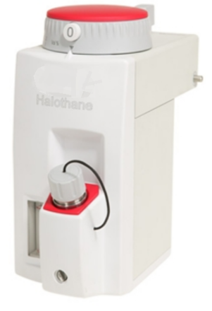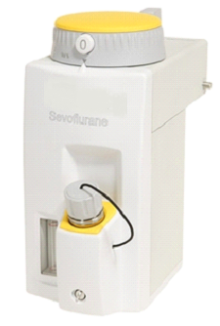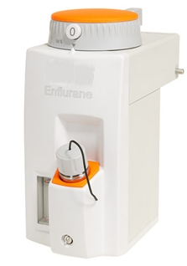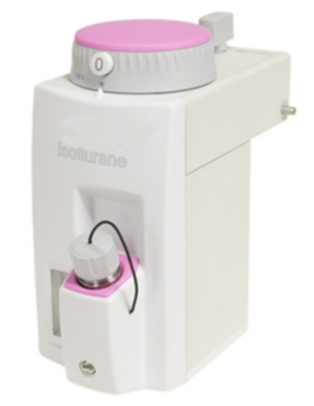

|  |  |
| --- | --- |
| Anesthesia gas | Adjustable scope % (volume percentage) |
| Halothane | 0 ～ 5 |
| Enflurane | 0 ～ 5 |
| Isoflurane | 0 ～ 5 |
| Sevoflurane | 0 ～ 8 |